**HW4 Writeup**

**Prepared By: Woon Kim**

**UNI: wk2371**

**Date: February 20 2022**

[1] The smallest loss achieved = 22.2594

[2] The corresponding learning rate = 0.00007

[3] The corresponding beta_hat = [1.95654638, 0.5067125, 2.9917436, 0.09249807]

[4] Number of updates used = 3159

[5]

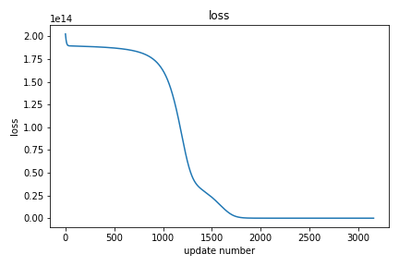

[6]

